Contractor ACH Information
Business Name: Eagle II LLC

Recipient (Contractor) Information
Contractor/Payee Name: RAYMOND C. LEE
Business Name: N/A
Address: 14306 Lenora Place North
City: Seattle State: WA ZIP: 98133

Bank Account Information
Bank Name: SoFi Bank, N.A
Bank Address: 2750 E Cottonwood Parkway, Suite 300
City: Cottonwood Heights State: UT ZIP: 84121
Routing Number (9 digits): 031101334
Account Number: 310017749171
☐ Checking Account ✅ Savings Account

Authorization
By signing below, I authorize the business named above to initiate ACH credit entries (direct deposits) to the account indicated above for payments due. I certify that I am authorized to receive deposits to this account.
Contractor Signature:
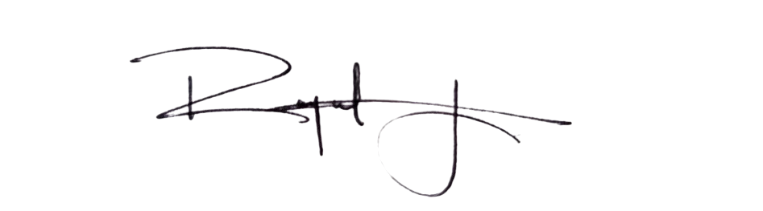
RAYMOND C. LEE

Date: 10/10/2025

Optional: Attachments
☐ Voided check OR
☐ Official bank letter confirming account and routing numbers

