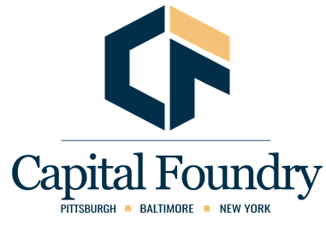

To wire or ACH to Capital Foundry Lending, LLC:

ABA Routing – 124384657
TAB Bank
Ogden, Utah

Credit Account No - 501127911

Customer Name & Address

Capital Foundry Lending, LLC
2740 Smallman Street
Suite 203
Pittsburgh, PA 15222
412-593-4294

