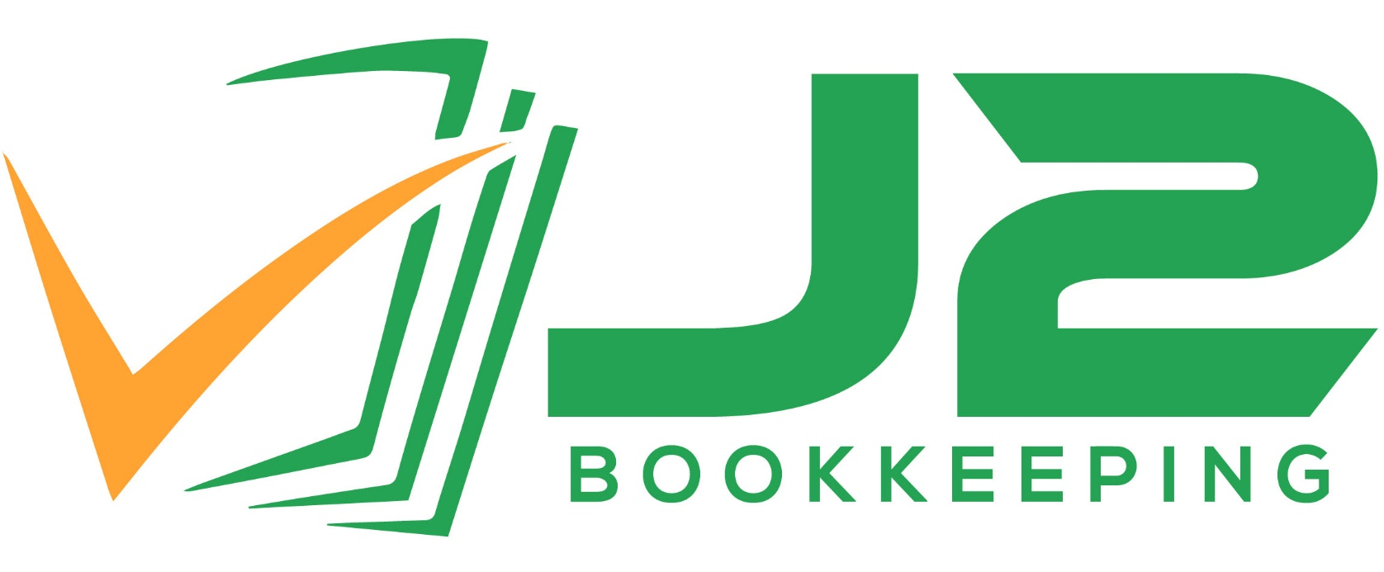

Bookkeeping
Service Agreement

Prepared for:

PAX Management – Agave

Created by:

Jimmie Needles
J2 Bookkeeping LLC
This Accounting Contract ("Contract" or "Accounting Contract"), in effect as of the Contract start date, is by and between the following parties:

"Client":
PAX Management – Patrizia Vallieri
615 Oxford Dr #105, New Braunfels, TX 78130
T: 512.618.2645 E: patrizia@paxmanagementtx.com

"Provider":

J2 Bookkeeping LLC – Jimmie Needles, Owner
513 Creekside Cir, New Braunfels, TX 78130
T: 210.970.0449 E: Jimmie@J2Bookkeeping.com

WHEREAS Client wishes to retain Provider for Bookkeeping Services described in this agreement, and Provider agrees to provide such services in consideration of the payments described herein, both parties agree to the terms of this contract as follows:

ENGAGEMENT

J2 Bookkeeping LLC has been engaged to provide bookkeeping cleanup and monthly bookkeeping services. The following tasks will be completed starting on the date listed below, providing this engagement letter is fully executed, and credit card authorization or ACH authorization is received.

- Monthly Bookkeeping Entry and classification of all financial transactions

- Bank and credit card account reconciliations

- Preparation of financial reports, including Profit & Loss and Balance Sheet

- Recommendations and reclassifications of transactions when necessary

- Other bookkeeping tasks as agreed upon by both Client and Provider (additional fees may be incurred, but will be agreed upon in advance)

- Participate with in-person meetings or virtual meetings such as ‘Zoom’ Calls, Telephone conferences, with other members of PAX Management team.
Annual Tasks
- Preparation and filing of 1099s as necessary (additional cost of $20 per 1099 for e-filing fees)

This Agreement does not include services that might be needed that do not relate to the normal operation of the business, such as the acquisition or sale of major assets, income modeling or forecasting, tax return preparation and filing, setup of new employees, employee terminations, employment verification, resending W-2s, correcting 1099s, reviewing and responding to IRS or state tax notices that are outside J2 Bookkeeping LLC’s scope or participation, property tax filings, and governmental agency audits. These services will be billed at a rate to be agreed upon when the need for specific services arises.

It is your responsibility to provide all the documents and information required for the preparation of your financial reports. You agree that effective communication can only occur if you give J2 Bookkeeping efficient and unrestricted access to your financial documents, records, and information and if you are responsive to questions, we ask about the information you provide.

To complete the services described herein, J2 Bookkeeping LLC must obtain the following documents. As business requirements may change, J2 Bookkeeping will dutifully communicate to PAX Management as the client any additional information that may be required. If these documents are not provided in a timely manner, delays can occur in the delivery of services. The required documents include:

- Bank and credit card statements for the period. We require read-only online access to all accounts.
- Verification documents for all bank deposits, i.e. deposit slips, invoices, cash register receipts, or summaries of sales and deposits IF needed for processing of work for client.
- Online access to the payroll processing service account.
- Copies of receipts for business-related purchases paid with cash register funds and/or petty cash funds.
- Receipts for business-related purchases paid with personal funds.
- A listing of accounts receivable and accounts payable.
- Copies of purchase and lease agreements for the acquisition and sale of major assets.
- Copies of loan, mortgage, line of credit, and other finance documents for reporting of liabilities.

Please note that other documents may be required during the course of this engagement.

You should retain all documents and all other material data that form the basis of your financial information. You also represent and agree that you are sole custodian of the original documents and data. Your original documents and data comprise the backup and support for your financial reports and tax filings. Although access to information will be shared with J2 Bookkeeping LLC, PAX Management retains sole ownership of all files, documents, and other information gathered, communicated, or provided by any means pertaining to PAX Management, its communities, vendors, and other partners. J2 Bookkeeping LLC may store shared information for a period of seven (7) years to satisfy any legal or professional needs in accordance to agreed partnership with PAX Management. Our firm will diligently dispose of client files in a manner maintaining all privacy for PAX Management, its communities, vendors, and other partners after the aforementioned timeline. Catastrophic events or physical deterioration may result in our records being unavailable.

In connection with this engagement, we may communicate with you or others via email transmission. As emails can be intercepted and read, disclosed, or otherwise used or communicated by an unintended third party, or may not be delivered to each of the parties to whom they are directed and only to such parties, we cannot guarantee or warrant that emails from us will be properly delivered and read only by the addressee. Therefore, we specifically disclaim and waive any liability or responsibility whatsoever for the interception or unintentional disclosure of emails transmitted by us in connection with the performance of this engagement. I PAX Management holds no fault to J2 Bookkeeping LLC and Jimmie Needles of any damages outside intentional disbursement of confidential or proprietary information.
Date to begin monthly services:01/01/2024 (unless notified that work needs to start sooner which may require additional fee)

Costs and Fees:
  - $100 monthly added to the current monthly of $350 for a total of $450 monthly plus QuickBooks fee. A $100 one time charge will be charged in January with the full amount starting February 1st 2024. This total includes the Mercer NB and Agave Lofts.

All invoices will be considered accepted by the client if not disputed within 30 calendar days from the date the invoice or sales receipt was generated. All invoices that are not in dispute will be paid in full and on time. Any disputes must be submitted in writing within 30 calendar days of the invoice date. By signing this agreement, the customer will agree to these terms.

Scope and Limitations

We may provide reports which contain portions of financial information. These reports are limited to information that are the representations of management. We will make no attempt to adjust the records to reflect generally accepted accounting principles (GAAP). We will only provide financial statements necessary in governance and in assistance with proper financial management of PAX Management and their partnered communities for internal management purposes and tax purposes These reports are not intended for third-party use. PAX Management understands that J2Bookkeeping LLC is not a Licensed CPA Firm and we do not provide assurance services.

We will not perform any compilation, review, or audit of any of the financial information. We have not been requested to discover errors, misrepresentations, fraud, illegal acts, or theft, and therefore, have not included any procedures designed or intended to discover such acts. You agree we have no responsibility to do so.

We do not at any time provide legal services of any type.

Termination of Engagement

Either party may terminate this relationship by providing thirty (30) day written notice of intent communicated by means of Certified Mail through USPS, or electronic communication such as Email. Intended recipient of the notice can verify receipt within 7 to 10 business days. If the recipient of notice is found to be unresponsive, separation will continue thirty (30) calendar days after written notice was initially provided. All existing projects or ongoing commitments must be completed without interference or request for additional tasks when notice of intent to terminate engagement has been provided by either party. Unless otherwise agreed upon in writing to include specific terms and conditions.

Limit of Liability

Client hereby agrees that J2Bookkeeping LLC or Jimmie Needles’ total liability for any breach of this Agreement, for any failure to perform any term of this Agreement, for any claims relating to or arising out of its performance of this Agreement, and for its own ordinary negligence in any aspect of its relationship with Client Outside of malicious intent or purposeful neglect regardless of form of action, shall be limited to the most recent monthly amount billed for services agreed to hereunder as its exclusive remedy. Client agrees that it shall not make any claim against J2Bookkeeping LLC or Jimmie Needles beyond such amount of monthly account, and J2Bookkeeping LLC and Jimmie Needles may rely on this paragraph as a complete bar to any such claim.

More specifically, Client agrees that J2Bookkeeping LLC and Jimmie Needles are not, and shall not be deemed to be, liable for any losses resulting from advice provided by them or either of them, or from work done by them, or for loss of profits of Client or of any other party which may flow therefrom, whether it be direct or incidental, whether or not they have been advised of the possibility of such damages, and Client acknowledges and agrees to the same hereto.

Neither party may bring any action arising out of the services described in this Agreement, regardless of form, more than one year after the date of the last services provided.

Indemnification

As an additional consideration for J2Bookkeeping LLC to provide Client these services, Client agrees to release, indemnify, defend, and hold harmless J2Bookkeeping LLC, its partners, officers, directors, members, employees, and agents from and against any and all claims, demands, suits, liabilities, losses, costs, and expenses (including attorneys’ fees) arising out of or in connection with any known misrepresentations or fraud participated in by management or any employees of Client, or such errors resulting from incomplete or inaccurate information provided by management or any employees of Client, and such indemnity shall not be limited to the term of this Agreement but shall be ongoing even after its termination.

Governing Law

J2Bookkeeping LLC and Client both agree that regardless of where the client is domiciled and regardless of where this Agreement is physically signed, this Agreement shall have been deemed to have been entered into at J2Bookkeeping LLC’s office located in Comal County, TX, USA and Comal County, Texas, USA shall be the exclusive jurisdiction for resolving disputes related to this Agreement. This Agreement shall be interpreted and governed in accordance with the Laws of TEXAS.

Complete Agreement

This Agreement is contractual in nature and includes all relevant terms that will govern the engagement for which it has been prepared. The terms of this Agreement supersede any prior oral or written representations or commitments by or between the parties.

Any material changes or additions to the terms set forth in this Agreement will only become effective if evidenced by a written amendment to this Agreement, signed by all parties. If any provision of this Agreement is determined to be unenforceable, all other provisions shall remain in force.

This Agreement is fully and voluntarily entered into by both parties. Each party states that he, she, or it has read this Agreement, has obtained advice of counsel if he, she, or it so desired, understands all of this Agreement, and executes this Agreement voluntarily and of his, her, or its own free will and accord with full knowledge of the legal significance and consequences of this Agreement.

If, after full consideration and consultation with counsel if so desired, you agree that the foregoing terms shall govern this engagement, please sign the copy of this Agreement in the space provided and return the original signed Agreement to me, keeping a fully executed copy for your records.

Acceptance
This contract is hereby approved and accepted by the authorized representatives of J2 Bookkeeping and Client as Listed on page 2 of this document.

For PAX Management

_________________________ ___________

Signature Date

For J2 Bookkeeping, LLC

_________________________ ___________
Jimmie Needles, Owner Date

